
Hamilton Middle School
Prices

Breakfast Free
Lunch Free
October/November
28  *Beef/Bean & Cheese Burrito  *Chicken Tenders w/Cheese Crackers  *Pepperoni Pizza Pocket  Cooked Garden Corn | 29  *Soft Shell Tacos  *Breaded Chicken Sandwich  Baked Beans | 30  *Apple Cinnamon French Toast w/Sausage Patties  *Cheese Stuffed Breadsticks w/Dipping Sauce  Cooked Green Beans | 31  *Beef Taco Sticks  *Popcorn Chicken Bowl  *Mini Corn Dogs  Fresh Broccoli | 01  *Chicken Cheese Quesadilla  *Mozz. Cheese Sticks w/Dipping Sauce  *Ham & Cheese Calzone  Cooked Garden Corn
04  *Chicken Leg w/Mashed Potatoes & Dinner Roll  *Pizza Bite Crunchers  Cooked Garden Corn | 05  *Pulled Pork Sandwich  *Sausage Egg & Cheese Bagel Sandwich  Baked Beans | 06  *Chicken Bacon Sandwich  *Cheese Stuffed Breadsticks w/Dipping Sauce  Cooked Green Beans | 07  *Deluxe Nachos  *Hot Dogs  *Strawberry Parfait w/Cereal Bar  *Pizza Pocket  Fresh Broccoli | 08  Half Day
11  *Chicken Egg Rolls  *Chicken Tenders w/Cheese Crackers  *Pepperoni Pizza Pocket  Cooked Garden Corn | 12  *Soft Shell Tacos  *Breaded Chicken Sandwich  Baked Beans | 13  *Apple Cinnamon French Toast w/Sausage Patties  *Cheese Stuffed Breadsticks w/Dipping Sauce  Cooked Green Beans | 14  *Beef Taco Sticks  *Orange Chicken Stir Fry w/Rice & Fortune Cookie  *Mini Corn Dogs  Fresh Broccoli | 15  *Chicken Cheese Quesadilla  *Mozz. Cheese Sticks w/Dipping Sauce  *Ham & Cheese Calzone  Cooked Garden Corn
18  *Chicken Leg w/Mashed Potatoes & Dinner Roll  *Italian Pull Apart Cheese & Garlic Bread w/Dipping Sauce  Cooked Garden Corn | 19  *Pulled Pork Sandwich  *Sausage Egg & Cheese Bagel Sandwich  Baked Beans | 20  *Chicken Bacon Sandwich  *Cheese Stuffed Breadsticks w/Dipping Sauce  Cooked Green Beans | 21  *Deluxe Nachos  *Hot Dogs  *Strawberry Parfait w/Cereal Bar  *Pizza Pocket  Fresh Broccoli | 22  *Ham & Cheese Calzone  *Corn Dog  *Chicken Nuggets w/Crackers  Cooked Garden Corn
25  *Beef/Bean & Cheese Burrito  *Chicken Tenders w/Cheese Crackers  *Pepperoni Pizza Pocket  Cooked Garden Corn | 26  *Soft Shell Tacos  *Breaded Chicken Sandwich  Baked Beans | 27  Thanksgiving Break  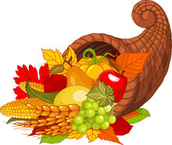 | 28  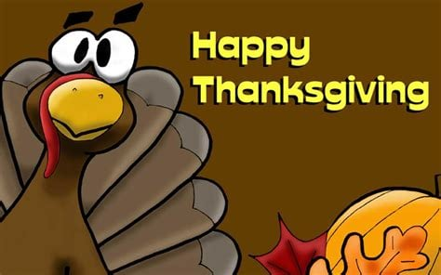 | 29  Have a Great Weekend

MONDAY TUESDAY WEDNESDAY THURSDAY FRIDAY

Monday Tuesday Wednesday Thursday Friday
Mini Pancakes | Choc. Chunk Benefit Bar | Whole Grain Mini Cinnamon Rolls | Whole Grain Apple or Cherry Frudels | Choc. Chip French Toast

Daily Breakfast Entrées Include: 100% Asst. Fruit Juices, Fresh and Asst.Canned Fruit.
1% White and Skim Chocolate Milk (Cereal Kits also available daily)

Available Daily
*Hamburgers/*Cheeseburgers/*Chef Salads
*Turkey & Cheese Sub Sandwiches/*Cheese & Pepperoni Pizza Hut Pizza

Due to product availability Menus are subject to change

*Included daily with lunch are several choices of fruit and vegetables.
Fruit Choices.
Apples, Oranges, Watermelon, and Grapes (seasonal), canned in juice, Peaches, Applesauce, Pears, Pineapple and Mandarin Oranges.
100% Apple, Orange and Grape Juice.
Vegetable Choices.
In addition to the daily hot choice, Fresh Baby Carrots, Celery and Broccoli.
Also 1% White and Chocolate Milk.
*All breads and breading are whole grain.

USDA is an equal opportunity provider and employer.
Breakfast
Breakfast Meal Deal
(1) Entrée Choice
(2) Fruit or Fruit Juice
(1) Low-Fat 1% or Skim Milk (8oz)

Lunch Meal Deal
(1) Entrée Choice (bread & protein)
(2) Fruit Choices
(2) Vegetable Choices
(1) Low-Fat 1% or Skim Milk (8oz)

